T

Cluster Configuration Requirements & Design

Product Suite | TIBCO BusinessEvents
Product | TIBCO BusinessEvents
Product Version | 4.0
Initial Author | Suresh Subramani

Copyright Notice
COPYRIGHT© 2008-2009 TIBCO Software Inc. This document is unpublished and the foregoing notice is affixed to protect TIBCO Software Inc. in the event of inadvertent publication. All rights reserved. No part of this document may be reproduced in any form, including photocopying or transmission electronically to any computer, without prior written consent of TIBCO Software Inc. The information contained in this document is confidential and proprietary to TIBCO Software Inc. and may not be used or disclosed except as expressly authorized in writing by TIBCO Software Inc. Copyright protection includes material generated from our software programs displayed on the screen, such as icons, screen displays, and the like.
Trademarks
Technologies described herein are either covered by existing patents or patent applications are in progress. All brand and product names are trademarks or registered trademarks of their respective holders and are hereby acknowledged.
Confidentiality
The information in this document is subject to change without notice. This document contains information that is confidential and proprietary to TIBCO Software Inc. and may not be copied, published, or disclosed to others, or used for any purposes other than review, without written authorization of an officer of TIBCO Software Inc. Submission of this document does not represent a commitment to implement any portion of this specification in the products of the submitters.
Content Warranty
The information in this document is subject to change without notice. THIS DOCUMENT IS PROVIDED "AS IS" AND TIBCO MAKES NO WARRANTY, EXPRESS, IMPLIED, OR STATUTORY, INCLUDING BUT NOT LIMITED TO ALL WARRANTIES OF MERCHANTABILITY OR FITNESS FOR A PARTICULAR PURPOSE. TIBCO Software Inc. shall not be liable for errors contained herein or for incidental or consequential damages in connection with the furnishing, performance or use of this material.
For more information, please contact:
TIBCO Software Inc.
3303 Hillview Avenue
Palo Alto, CA 94304
USA
Table of Contents
Change Log 4
1.1 Related Documents 4
2 Introduction 5
2.1 Purpose 5
2.2 Scope 5
2.3 Audience 5
2.4 References 5
3 Acronyms and Vocabulary 6
4 Old Packaging and Deployment Model 7
5 Roles 8
5.1.1 Packager 8
5.1.2 Deployer 8
6 Artifacts 9
6.1 Enterprise Archive (EAR file) 9
6.2 Cluster Deployment Descriptor (CDD file) 9
6.3 Wrapper configuration (TRA file) 9
6.4 Processing Unit Identifier (PUID string) 10
7 Life cycle 11
7.1 Packaging 11
7.1.1 Open the eclipse project 11
7.1.2 Build the Enterprise Archive 11
7.2 Deployment preparation 11
7.2.1 Open the eclipse project 11
7.2.2 Switch to Deployment Perspective (?) 12
7.2.3 Create the CDD 12
7.3 Deployment 12
8 Execution Model 13
8.1 Command Line Execution 13
8.2 Running from TRA 13
8.3 Running from EMM 13
9 Migration Strategy 14
9.1 EAR File 14
9.2 TRA File 14
Appendice A: Schema 15

Change Log
.
Date | Version | Name | Description
6/12/09 | 0.1 | Suresh | Initial Document Creation
6/23/09 | 0.2 | Gabe Grigorescu | Added more details to design, including pictures from subsequence meetings, fixed other doc issues
10/08/09 | 0.3 | Nicolas Prade | Rewrote outdated sections.

Related Documents
Document Title | Revision Number | Author
User Guide | 3.0 | Jackie Pascoe
Enterprise Management and Monitoring Tools |  | QL

Introduction

Purpose
The purpose of this document is to gather the BusinessEvents Deployment model and define its requirements.

Scope
- Functional requirements of the new BusinessEvents Deployment model.
- Migration strategy from pre-4.0 to 4.0.
- Compatibility requirements to run in TIBCO Administrator.
- Design and implementation constraints if any.

Audience
- Developers
- Architects
- Quality Assurance
- Product Marketing
- Product Management and Support.

References

Acronyms and Vocabulary

The table below describes some of the Acronyms used in this documentation
- BE – TIBCO BusinessEvents.
- EAR - Enterprise Archive
- SAR - Shared Resource Archive
- BAR - BusinessEvent Archive
- Cluster
- Agent
- Deployment
- CDD – Cluster Deployment Descriptor

Old Packaging and Deployment Model
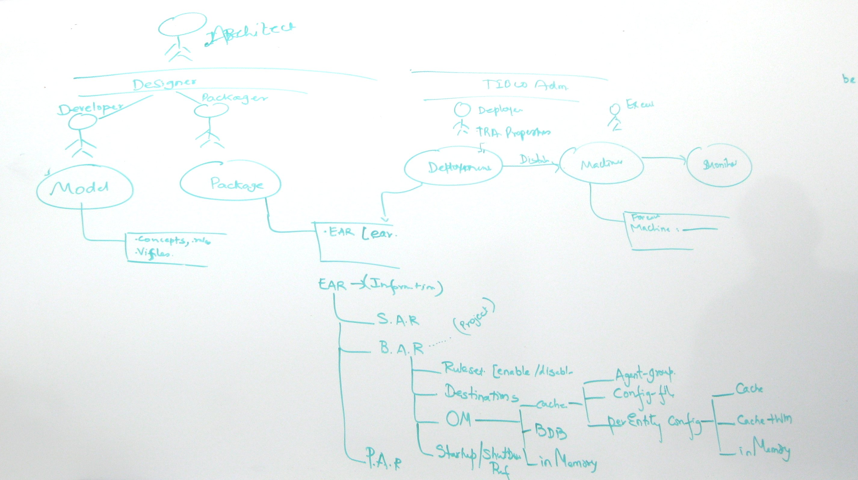

Roles

Packager
- Uses eclipse.
- Selects and opens a BusinessEvents design-time project.
- Builds an Enterprise Archive (EAR) package.

Deployer
- Uses eclipse, and EMM or Administrator.
- Opens a BusinessEvents design-time project.
- Creates a Cluster Deployment Descriptor (CDD) file.
- Makes the CDD, the EAR, and a processing unit identifier available to every engine.
- Uses EMM or command line to start the engine.

Artifacts

Enterprise Archive (EAR file)
The enterprise archive file (EAR) is a read-only ZIP file created by packaging the project.

Contents
- TIBCO.xml - global variables and Administrator information
- beArchiveName.bar
  - TIBCO.xml - startAsOneOf and other Administrator information
  - be.jar - compiled classes
- Shared Archive.sar
  - All design-time project files (not just the usual “shared resources”).

Notable changes from 3.x
The EAR does not contain anymore:
- /beArchiveName.bar/engine-config.xml – The data has been moved to the CDD.
- /bwArchiveName.par – BW archives are generated separately

Cluster Deployment Descriptor (CDD file)
The Cluster Deployment Descriptor CDD is a modifiable XML file created using the design-time project.
In BusinessEvents 3.0 terminology, the CDD is a merge of the BAR content and the TRA properties.

Overview
The CDD includes configuration information at different levels:
- Agent level. An agent is one configured instance of:
  - Inference agent: runs a rule session.
  - Cache agent: stores cached data.
  - Query agent: can query the cache.
  - Dashboard agent: …?
- Agent class level. An agent class contains the configuration shared by one or more agents. Optionally, the agents in a same agent class can participate in a fault-tolerance scheme.
- Processing unit level. A processing unit runs one or more agents in a single JVM.
- Cluster level. A cluster groups one or more processing units that can communicate with each others.

Details
See the appendix.

Wrapper configuration (TRA file)
The TRA file is obtained by installing BusinessEvents in the runtime environment.
It now contains only bootstrap information:
- Paths
- JVM parameters
- Possibly some implementation-level choices, such as: XML parser classes, event payload serialization classes, etc.
Other info previously located in the TRA should now be in the CDD.

Processing Unit Identifier (PUID string)
The PUID is a string that identifies a unique processing unit within a given CDD.
It is used by a BusinessEvents engine to identify the processing unit that the engine must run.

Life cycle

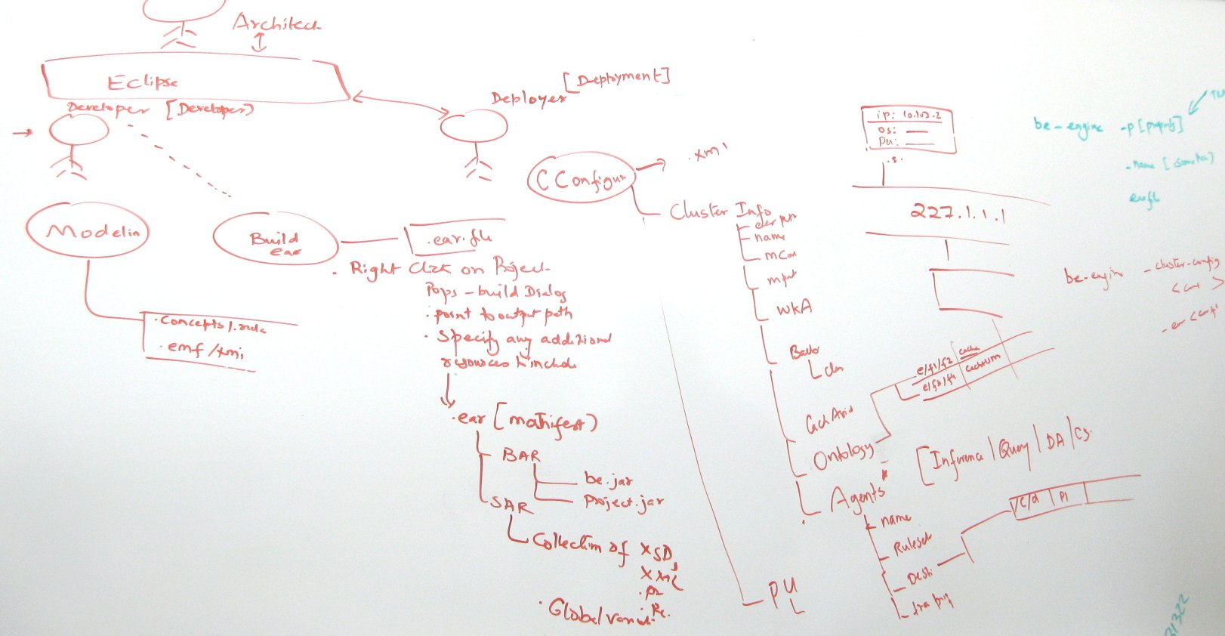

Packaging

Open the eclipse project
The Packager uses eclipse to open a Business Events design-time project.

Build the Enterprise Archive
The Packager selects the project, and uses the menu “Build Enterprise Archive” (either from a top menu or from the context menu). This pops up a dialog box with the following inputs:
- Project name
- Author
- Description
- Archive version
- EAR file location
Once done, the Packager obtains an EAR file that can be transmitted to the Deployer.

Deployment preparation

Open the eclipse project
The Deployer uses eclipse to open a Business Events design-time project.

Switch to Deployment Perspective (?)
A Deployment Perspective (TBD) may be provided in eclipse to focus on deployment related tasks.

Create the CDD
The Deployer organizes its cluster configuration (into cluster, processing units, agents, agent classes, etc). A CDD editor will be provided.
The Deployer then saves the CDD and uses it for deployment.

Deployment

Using Enterprise Monitoring and Management tool (EMM)
The Deployer can use EMM to identify target machines, specify processing units, and deploy the EAR + CDD. Please see the EMM documentation for details.

Using Administrator
TBD.

Using the command line
The Deployer identifies the machines (nodes) that must run a BusinessEvents engine.
Then, for each engine, on each machine:

Make artifacts available
The Deployer makes the EAR and CDD available to the BusinessEvents engine. For example, the EAR and the CDD can be copied to a file system location accessible by the engine.
The Deployer chooses from within the CDD the ID of the processing unit to run (PUID).

Start the engine
The Deployer starts the engine by starting the wrapper. Some parameters must be supplied in order to specify the EAR, the CDD and the PUID. The general format is:

be-engine -c CDD -u PUID EAR

For example:

be-engine -c cluster1.cdd -u feeder02 myapp.ear

Stop the engine
This has not changed in 4.0.

Hot deployment
TBD

Migration Strategy

EAR File
Read the engine-config.xml and all BEArchive resources, and convert them into a single CDD.

TRA File
TBD

Appendice A: CDD Schema
The schema namespace is: http://tibco.com/businessevents/configuration/2009/09
The schema is stored in be/leo/common/src/com.tibco.be.util.config.schemas/config-2009-09.xsd

Appendice B: Suggested CDD building recipe

Start with a sample CDD.
There should be one along with the schema in SVN.

Pick a name
Choose a simple name for your CDD, e.g. TestCluster, and name your file accordingly, e.g. TestCluster.cdd
In the CDD, place the name in /cluster/name
<be:cluster
xmlns="http://tibco.com/businessevents/configuration/2009/09/concrete"
xmlns:be="http://tibco.com/businessevents/configuration/2009/09"
xmlns:xsi="http://www.w3.org/2001/XMLSchema-instance">
<name>TestCluster</name>
…
</be:cluster>

Set up object management
Currently only in-memory is implemented on the CDD side.
…
<object-management>
<domain-objects>
<default-mode>memory</default-mode>
</domain-objects>
<memory-manager />
</object-management>
…

Create rule groups
/cluster/rulesets contains groups of rules that can be run by an agent.
Each group is a <rules> element. Give it an id attribute (with a unique value!). Groups contains <uri> elements that specify the URI of a rule in the design time project.
…
<rulesets>
<rules id="r-1">
<uri>/Rules/OnSuccess</uri>
<uri>/Rules/OnFailure</uri>
</rules>
…
<rules id="r-96">
<uri>/Rules/OnIncomingEvent</uri>
</rules>
</rulesets>
…

Create rule function groups
Same principle as for rules, at /cluster/function-groups:
…
<function-groups>
<functions id="startup-1">
<uri>/Functions/Startup1</uri>
<uri>/Functions/Startup2</uri>
<uri>/Functions/Startup3</uri>
</functions>
…
<functions id="shutdown-1">
<uri>/Functions/Shutdown1</uri>
<uri>/Functions/Shutdown2</uri>
</functions>
…
</function-groups>
…

Create end point groups
This follows more or less the same principle as for rules and rule functions, at /cluster/endpoint-groups.
For each end point (a.k.a. destination), you can provide additional information, such as the URI of a preprocessor rule function, a specific threading model, etc.
…
<endpoint-groups>
<endpoints id="endpoint-group-A">
<endpoint id="endpoint-1">
<uri>/Channels/RV/orders.in</uri>
<pre-processor>/Functions/OrdersPP</pre-processor>
<threading-model>shared-queue</threading-model>
<thread-count>3</thread-count>
<queue-size>50</queue-size>
</endpoint>
<endpoint id="endpoint-2">
…
</endpoint>
</endpoints>
</endpoint-groups>
…

Create agent classes
An agent class defines an agent configuration. That configuration can be shared amongst several agents.
Different agent class types use different agent class elements, which have different properties: cache-agent-class, dashboard-agent-class, inference-agent-class, query-agent-class.
For example, in an inference agent class, you will define which rules the agents will run, by referring to the <rules> groups that you listed earlier. Similarly you will choose which endpoints are enabled, which startup and shutdown functions will be used, etc.
…
<agent-classes>
<inference-agent-class id="ia-1">
<rules><!-- agents of this class run all rules from groups r-1, r2 and r-37-->
<ref>r-1</ref>
<ref>r-2</ref>
<ref>r-37</ref>
</rules>
<endpoints>
<ref>endpoint-group-A</ref>
<ref>endpoint-group-B</ref>
</endpoints>
<startup>
<ref>startup-1</ref>
</startup>
<shutdown>
<ref>shutdown-2</ref>
</shutdown>
</inference-agent-class>
…
<cache-agent-class id=”ca-3”>
…
</cache-agent-class>
</agent-classes>
…

Create processing units to run agents
Processing units host the agents that implement your application.
You must give them an ID, which you will use to instruct the engine on which processing unit to run.
List all the agents that need to run. Each agent is defined as an instance of an agent class.
…
<processing-units>
…
<processing-unit id="unit22">
<agents>
<agent>ia-1</agent>
<agent>ia-2</agent>
<agent>ia-2</agent>
<agent>ia-2</agent>
</agents>
</processing-unit>
…
</processing-units>
…

